Averi App

(Duo App Portfolio)

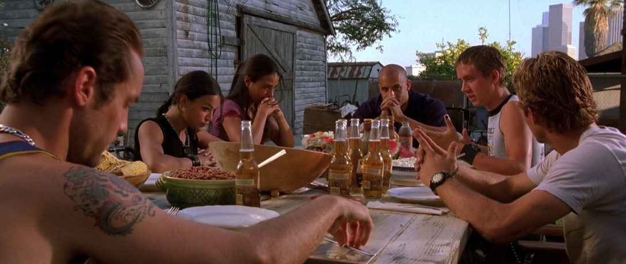

Personas
James is from The United Kingdom. Last year he applied for university in Eindhoven. He got accepted and came to the city with no friends. One of the first things James would like to do is find some fellow students to enjoy a night out with and possibly make some new friendships. And here comes our app. When James gets our app he will be able to browse through a list of small events near him and if he likes one of the parties he can easily join.

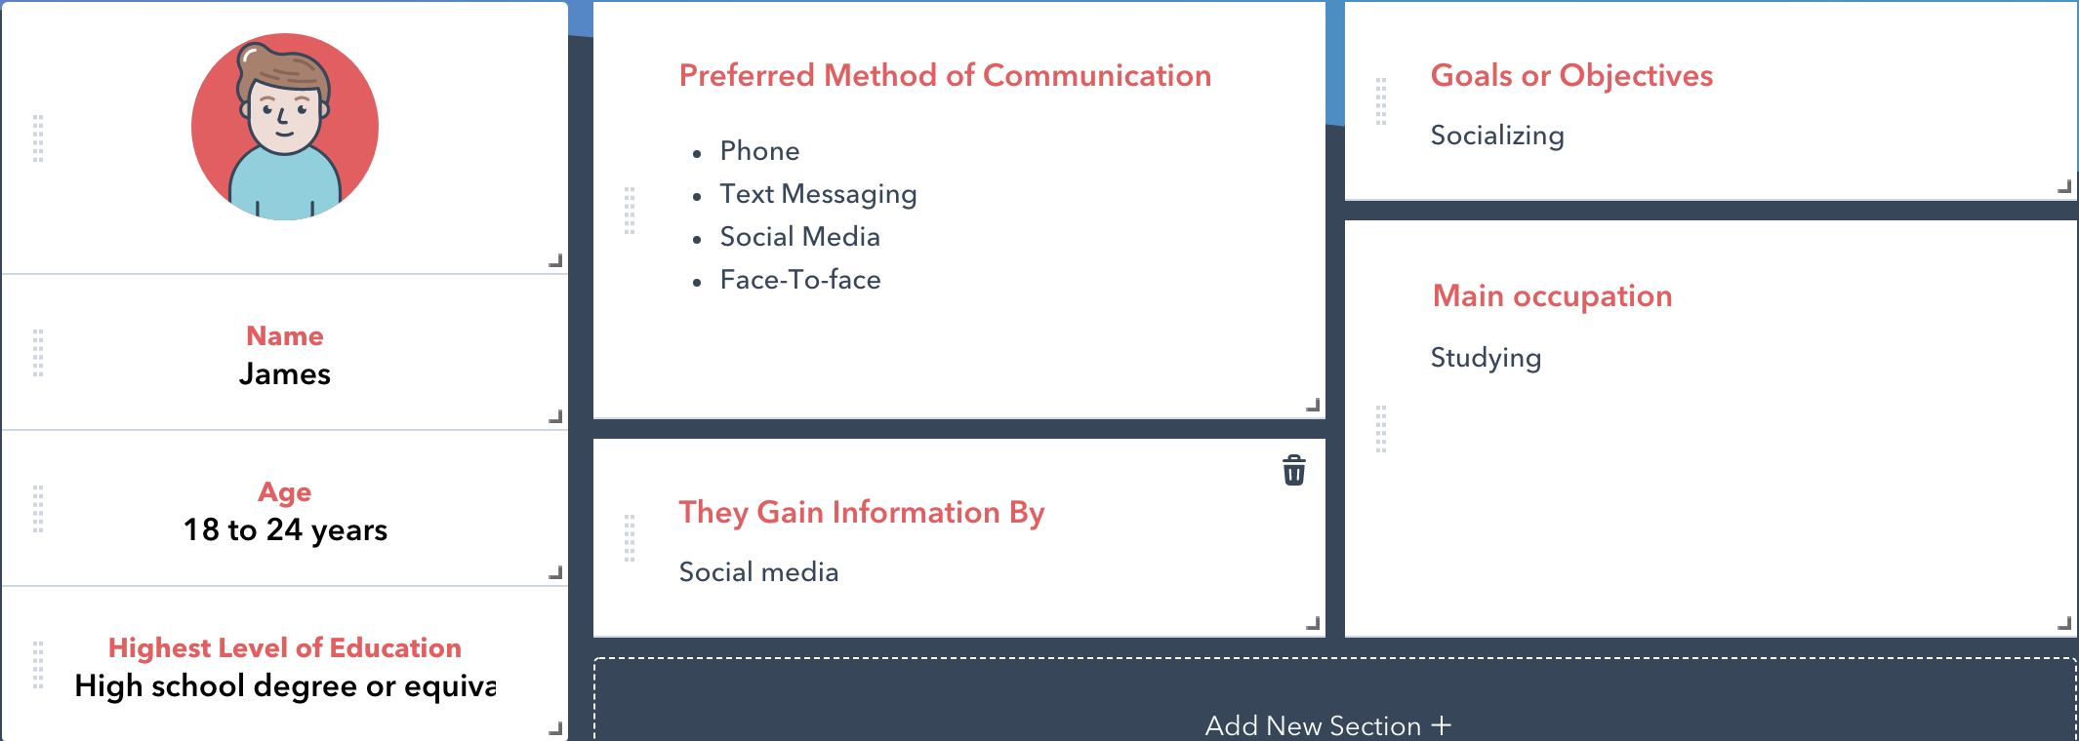

Maria is a student from Spain. She studies International Business in Eindhoven and this Saturday it's her birthday, so she wants to organize a party to celebrate, but she is living in Eindhoven since 2 months so she doesn’t have a lot of friends.She thinks her Birthday will be a great opportunity to meet up with new people. She knows an app for organizing private, cheap parties for finding new friends. She downloads the app and the first thing she has to do is make a registration. After signing up the interface shows her the local parties coming in the following days, but right now she wants to create one, so she goes to the tab for creating a party. She types the name and description of the party, chooses the date, time, location and puts a limit of 20 people who can join her Birthday Party. It’s her birthday so she chooses that there will be no entry tax or anything necessarily for people to bring when they come. After creating the party Maria tells her 3 close friends to join the party in the app. Two days before her birthday the party limit is reached so Maria expects 20 people to turn up this Saturday. The day before her birthday she buys all the food and drinks and she can’t wait more for tomorrow. After the weekend Maria is very happy that her party went so great, she found new friends. Next time she organizes a party she will use the app again.

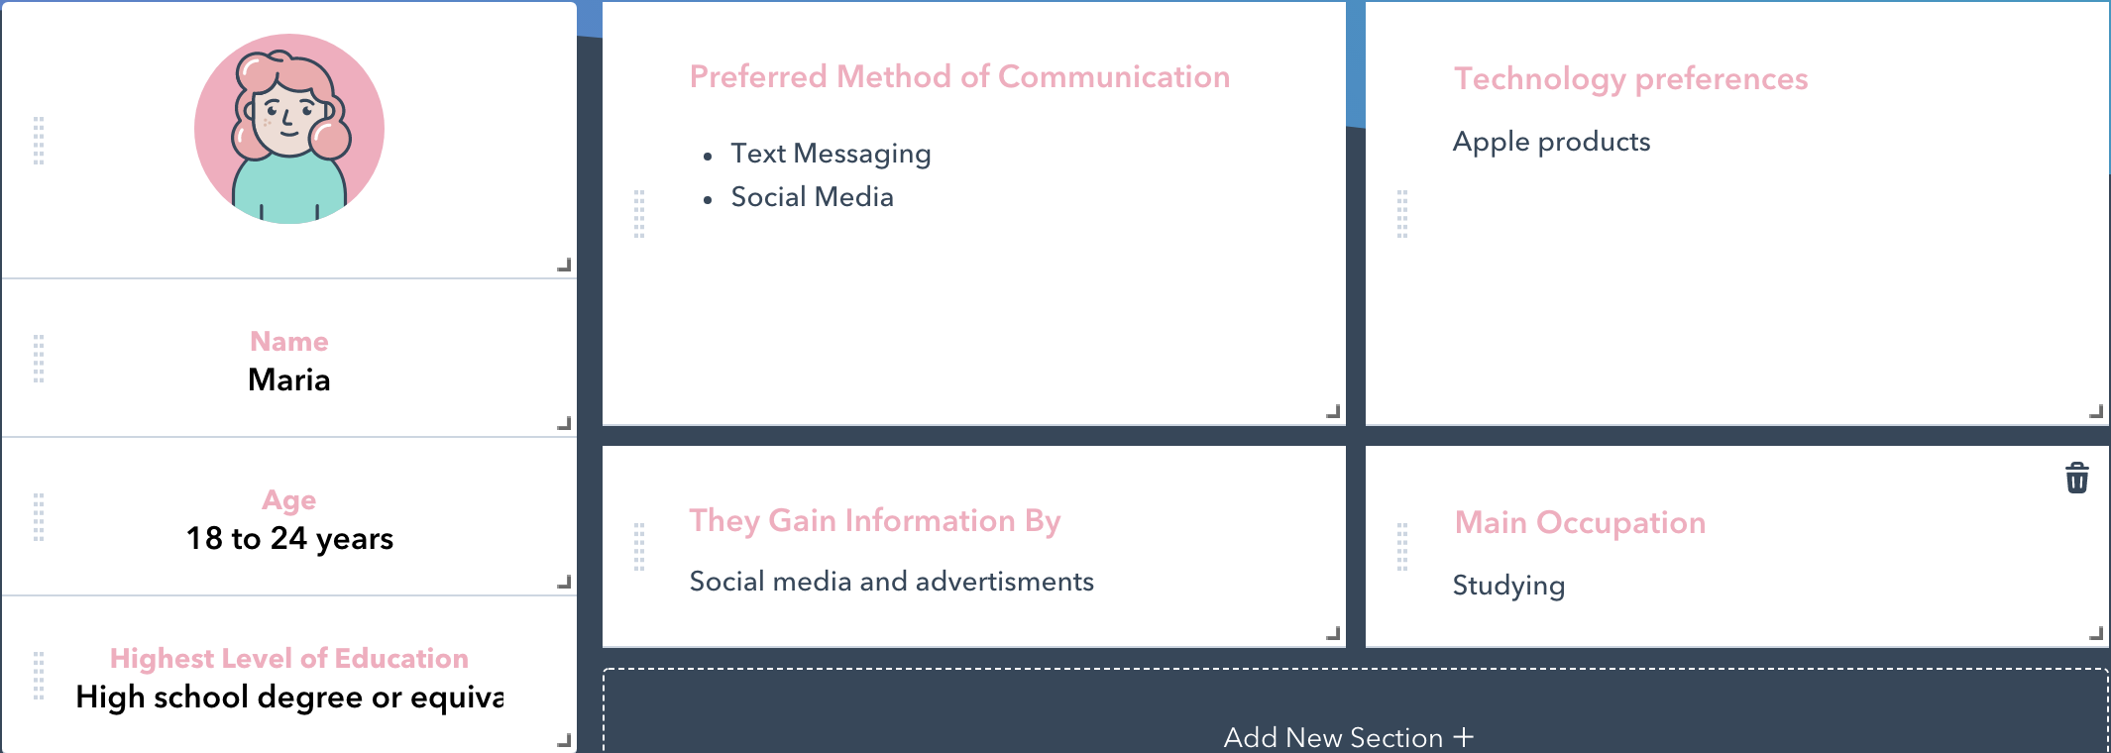

Scenarios

- a worst case scenario
A worst-case scenario will be, if no one comes to your party and you organized everything for nothing
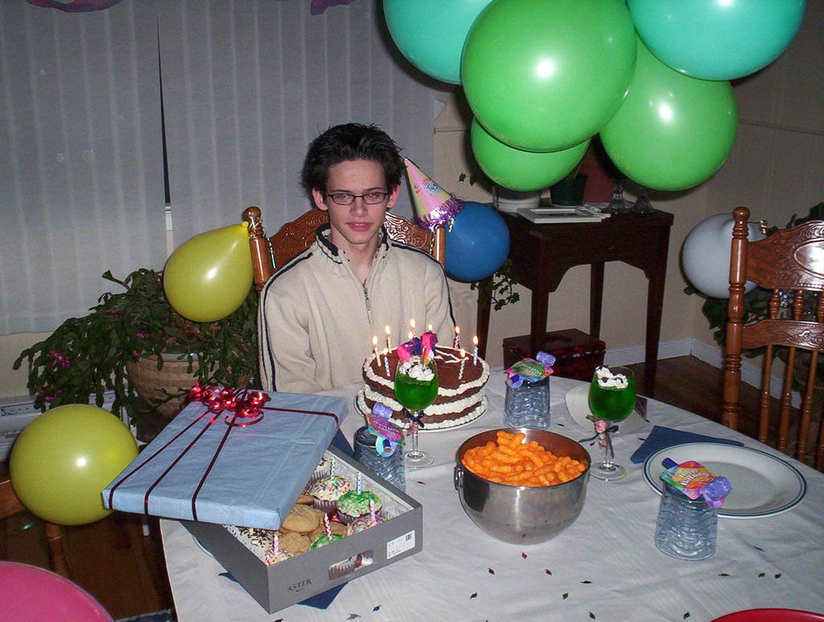

- an ideal scenario
An ideal scenario for our personas is just having fun at the event and maybe get some good friends out of it.


- a horror scenario
A horror scenario for that personas can be either they are the host or they are guests at a party and some disaster a happens. For example someone can leave something made of paper or cotton on a gas stove. That may cause a big fire or even explosion involving police, firefighters. Another horror case scenario can be: People get too drunk and destroy the house of the host.
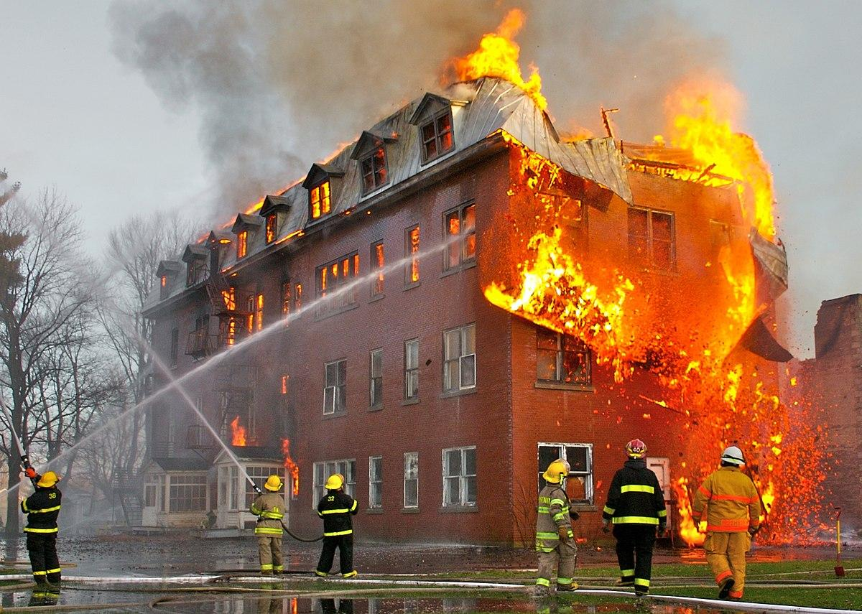

- gold plated superscenario
A gold plated super scenario for that personas can be going to a party and find two or three really good lifetime friends.

